Planning Sheet Name: Harold Pham

Goal: | Make a zombie apocalypse text-based game kind of like Oregon Trail.

Potential Barriers to Success & Resolution
Barrier 1 | Time limitation: Work as much as I can and focus
Barrier 2 | A lot of probability work: Set premade variables for the chances
Barrier 3 | I might’ve given the user too much resources: Will reduce items
Barrier 4 | Don’t know how to give the user more interface: I will try work out one path and if I have more time I will work on the other paths.
Barrier 5 | How will I organize the fighting system?: I’ll probably add a nice little story to it based off the chance.

Communication Plan
How is progress shown? | Maybe I can add a method in the game to initiate a specific event to skip in time and show what happens in the middle of the game.
How is Comp. Sci. & 21st Century Skills learning shown? | I will try to organize my presentation and show what each class does.
How will you know you exceeded, met, or didn’t met goal? How is your project being evaluated? | I will know based off of my vocal performance. If I keep messing up then I don’t think I did this well.
How are you communicating your project results to target audience? | I will show different endings for the game.

Tasks/Goals: (include screen shots of progress) | Projected | Actual
Project Proposal | 5.20.19
- Set up story | 5.21.19 | 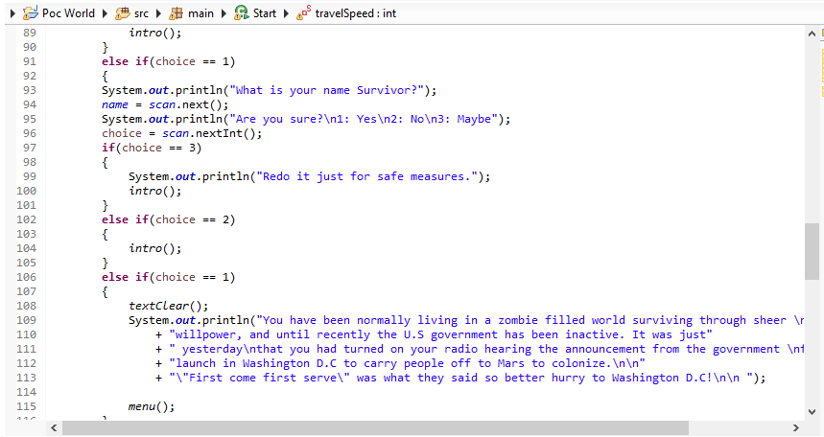
- Set up objects & loot system | 5.22.19 | 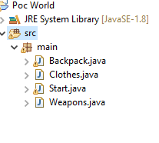
- Set up the map and obstacles user will go through including events and distance travel. | 5.23.19 | 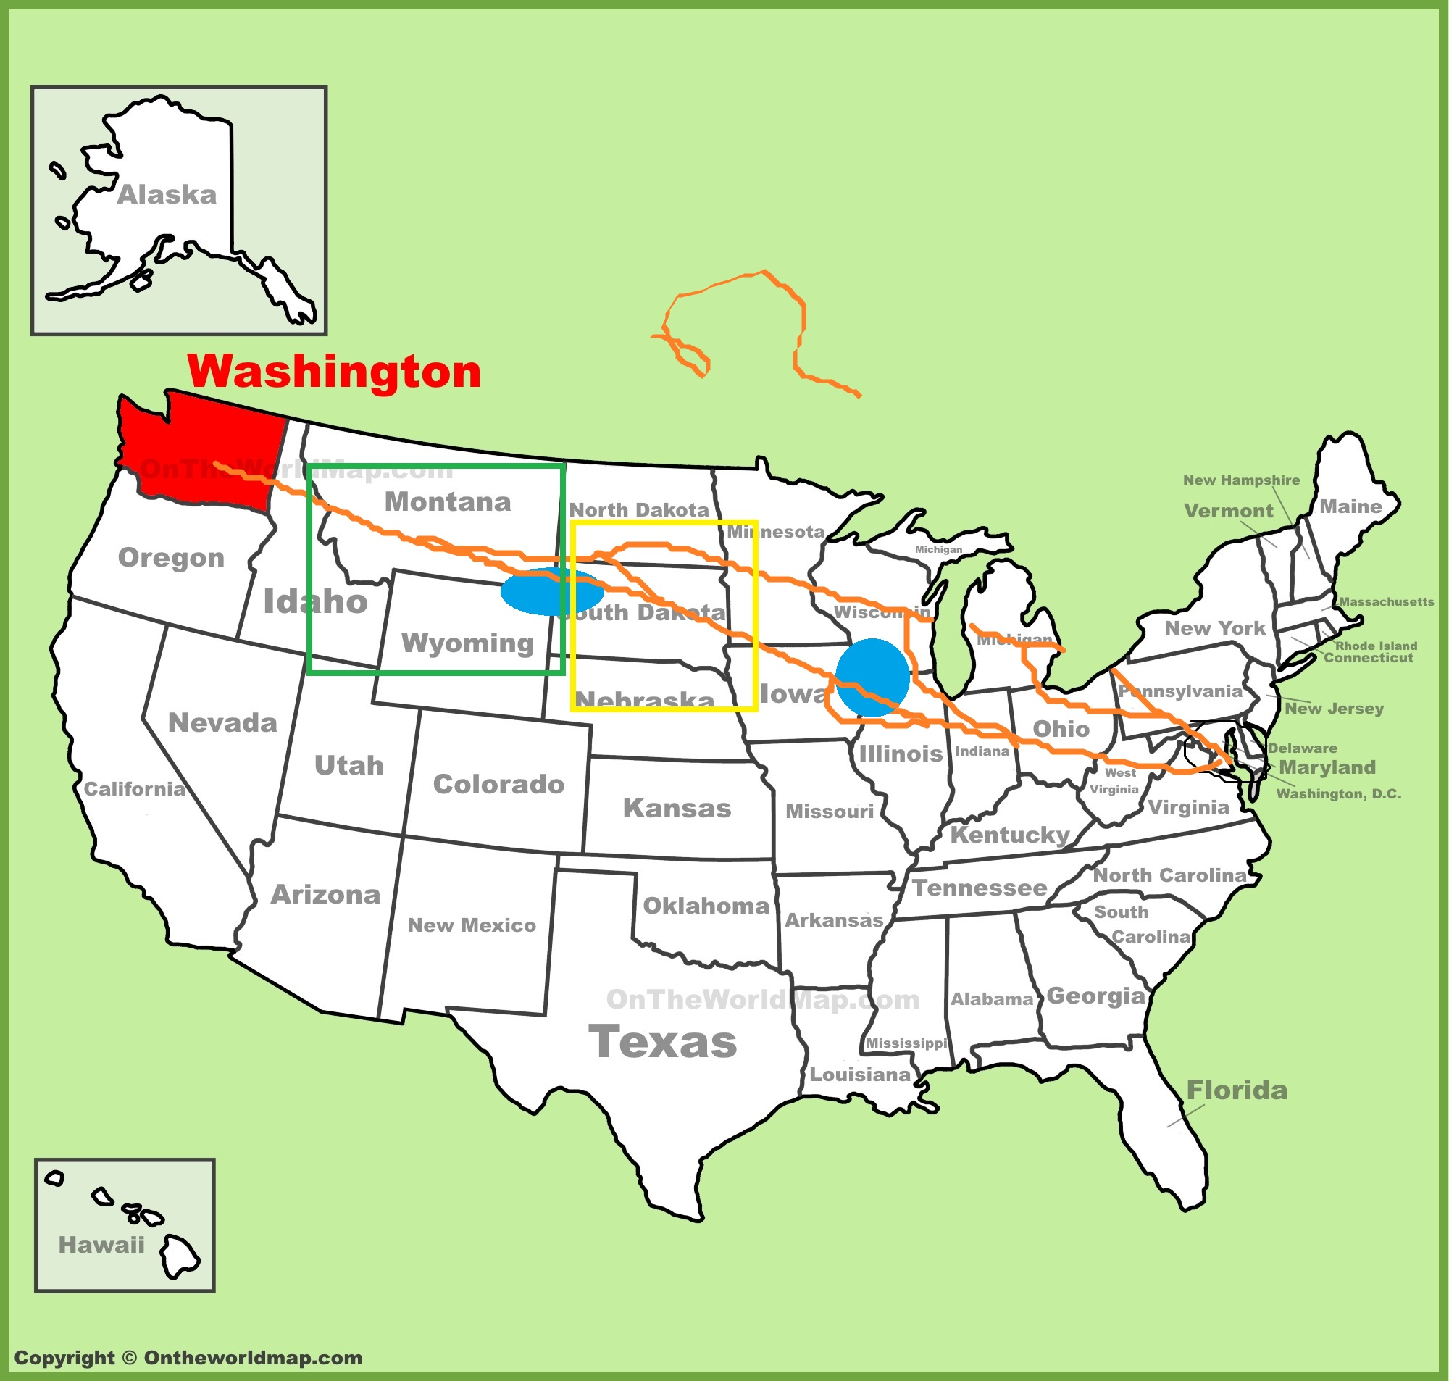
- Continue map set-up and event system. | 5.24.19  (Eval & Reflect) | After 50 miles traveled event chance will be chosen.
 | 5.28.19
 | 5.29.19
 | 5.30.19
5.31.19
(Eval & Reflect)
 | 7.3.19
 | 7.4.19
 | 7.5.19
7.7.19
(Eval & Reflect)
 | 7.10.19
 | 7.11.19
Present Project Product | 7.12.19  (Eval & Reflect)

Problems | Adjustments

21st Century Skills | Explanation
Communication | To be able to formulate the correct words to describe yourself or something.
Presentation | Be able to lead others through the thought process presented in the work.
Critical thinking | Be able to think ahead and concisely.
Flexibility | Be able to adapt to unexpected or new events
Technology literacy | Be able to use technology well.

Programing Skills | Explanation
Use most of the skills we’ve learned in the past year | Having the skills in the back of our mind to be able to use at moment notice.
Understanding of goal | With this you will be able to utilize the skills easier.
Effective use of skills | Be able to use the right skill in the right situation.
Use of the IDE | BE able to use the environment effectively.
Use of organization | Be able to organize your stuff.

Reflection
Looking at your goal, did you meet your goals? If not, why? (Be specific.)

What were your biggest struggles as you progressed through quarter 1? Where did you go specifically to solve problems? From what/who/where did you get the most help?

What have you enjoyed doing the most? Why?

What have you enjoyed doing the least? Why?

If you have been working as part of a team, explain in detail each person’s contributions towards the product that you currently have. Be specific. (May use other side.)

